**Male Female Classification using Naive Bayes Classifier**

To classify names as male or female using a Naive Bayes classifier, we'll use the frequency of specific features (e.g., last letter of the name) as predictors. Here’s an example:

**Dataset**

Consider the following dataset of names:

|  |  |
| --- | --- |
| Name | Gender |
| John | Male |
| Mary | Female |
| Paul | Male |
| Linda | Female |
| Steve | Male |
| Sarah | Female |

We extract the **last letter** of each name as a feature.

|  |  |  |
| --- | --- | --- |
| Name | Last Letter | Gender |
| John | n | Male |
| Mary | y | Female |
| Paul | l | Male |
| Linda | a | Female |
| Steve | e | Male |
| Sarah | h | Female |

**Steps to Solve**

1. **Prior Probabilities:**

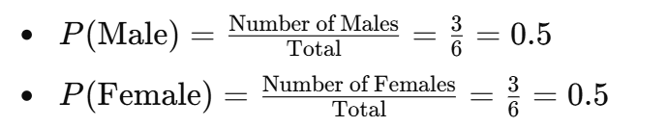

1. **Likelihoods:**

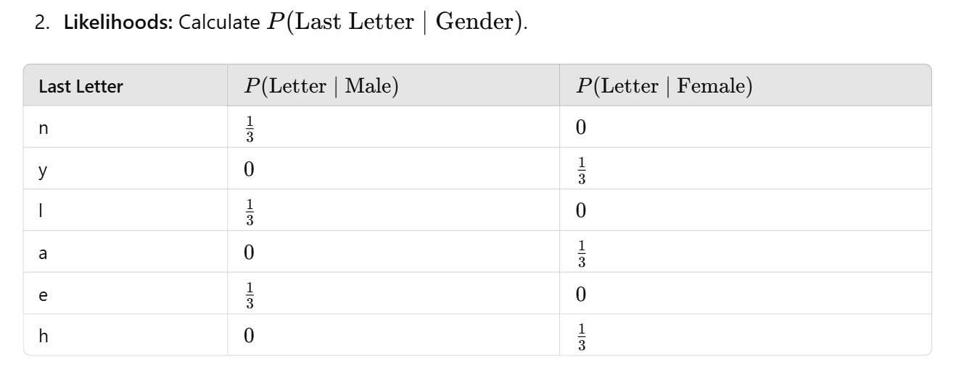

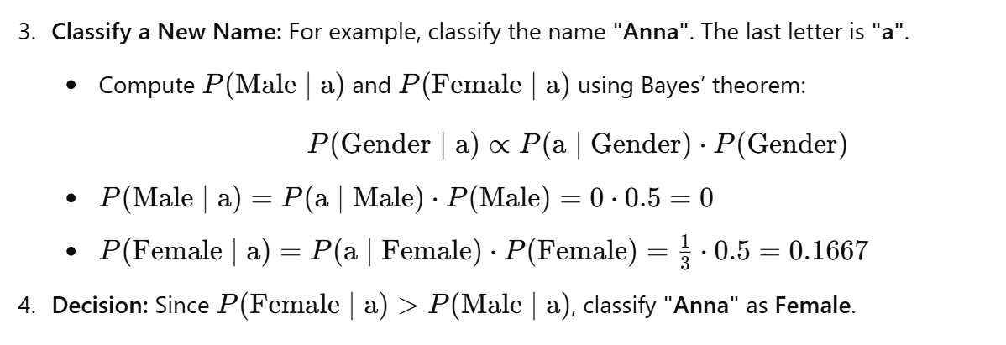

This is a simple example of how a Naive Bayes classifier works for male-female name classification. For a real-world scenario, a larger dataset and more features (e.g., entire name, vowels/consonants) would be considered.

The reason we often don't explicitly calculate P(a) in the Naive Bayes formula is that it's a common denominator that doesn't affect the classification decision. Let me explain in detail: